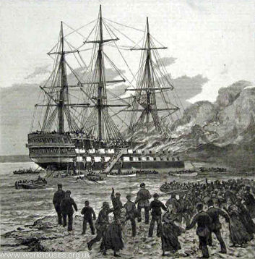Training Ship Goliath on Fire, 1875 .© Peter Higginbotham

18The Goliath and Exmouth
From 1870-75, the Forest Gate School District operated a ship called the Goliath moored on the Thames. It provided boys from all London's Poor Law authorities with training to help equip them to enter the Royal or Merchant Navy. The scheme proved highly successful, but the ship was destroyed by fire on 22nd December 1875 with the loss of twenty-three lives.75In 1877, a replacement vessel, The Exmouth took over the role, now moored off Grays in Essex and was managed by the Metropolitan Asylums Board. The Exmouth was an old wooden two-decker line-of-battleship, built in 1854, which had carried the flag of Admiral Seymour in the Baltic during the Crimean war. A news report in June, 1877, recorded an official visit to the ship.

Boys were able to join the ship from the age of twelve. Their first task was to learn how to mend and patch their own clothes. They also had to learn how to wash their clothes, and keep their lockers and contents in good order. Each boy had his own hammock which was stowed during the day, leaving the decks clear of bedding. As well as learning the skills of sailing, rowing, sail and rope-making, gunnery, and signalling, they continued ordinary school work, and other physical activities such as swimming and gymnastics. The ship had its own band and bugle-band.
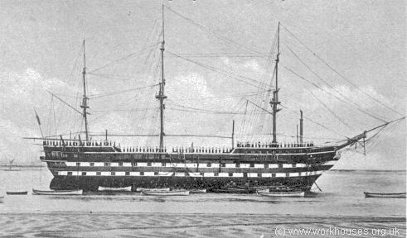
The original Exmouth, c.1903 © Peter Higginbotham

In 1892, admission to the ship was extended for up to 50 boys from parishes and unions outside the metropolitan Poor Law Area. In 1896, 137 boys entered the Royal Navy from the Exmouth (compared with a total of 135 from all other training ships in the country combined). In 1899, of 372 boys discharged from the Exmouth, 149 entered the Royal Navy, 135 the mercantile marine, 58 joined the army as musicians, and 30 returned to their respective parishes.
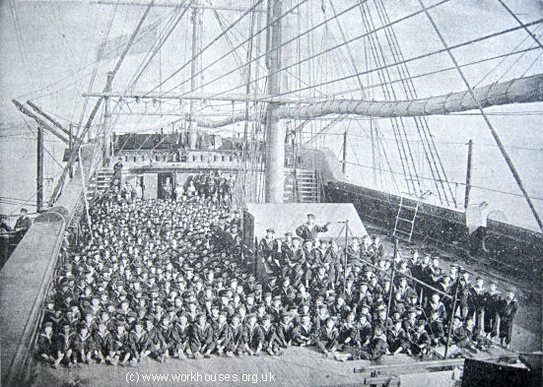
Training ship Exmouth, 1893 © Peter Higginbotham
In 1903, the ship's hull was found to be in an unsafe condition and was condemned. A replacement of similar appearance, but built of iron and steel, was commissioned from the Vickers company in Barrow-in-Furness. The new Exmouth was towed round the coast to Grays where she was inaugurated in August 1905.
The Exmouth had a companion ship, a brigantine called the Steadfast, used for cruising and to provide the boys with practical training in seamanship. The original Steadfast was condemned in 1894 and replaced by a new vessel of the same name.
Onshore at Grays, a playing field, swimming bath, and infirmary were provided in an old manor house called Sherfield House.
In 1945, the new Exmouth became HMS Worcester, the third and last training ship under that name, as part of the Thames Nautical Training College. She continued in service until the college's closure in 1968 and was broken up a few years later.
The new Exmouth, c.1905 Peter Higginbotham
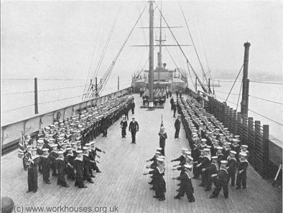©

Exmouth boys, c.1929 © Peter Higginbotham

